**In-Class Lab:**

1. Create Python Project with the name Lab2
2. Create a Python file called retail_item.py

In file retail_item.py

Create a main function as follows:

def main():

pass

if __name__ == “__main__”:

main()

1. Create the following functions:

* Function with the name get_retail_item_description(), the function prompts the user to enter the retail item description and returns it.
* Function with the name get_number_of_purchased_items (), the function prompts the user to enter the quantity sold and returns it.
* Function with the name get_price_per_unit(), the function prompts the user to enter the price and returns it.
* Function with the name get_tax_rate(), the function prompts the user to enter the tax rate as a floating point value and returns it.
  + For example, if the tax rate was 6% the user should enter the value 0.6.
* Function with the name calculate_subtotal(), the function takes two parameters the price, and quantity_sold . The function calculates and returns the subtotal amount. Subtotal is calculated by multiplying the price of the retail item times the quantity sold.
* Function calculate_tax(), the function takes two parameters the subtotal and the tax, the function calculates and returns the tax amount of the given subtotal.
* Function calculate_total(), the function takes two parameters subtotal and tax. the function calculates and returns the total amount
* In function main() remove the keyword pass and call functions to implement the following:

Get the retail item description, quantity sold, price and tax from the user

Calculate the subtotal, tax amount and the total. Finally display the result of calling functions in the following format:

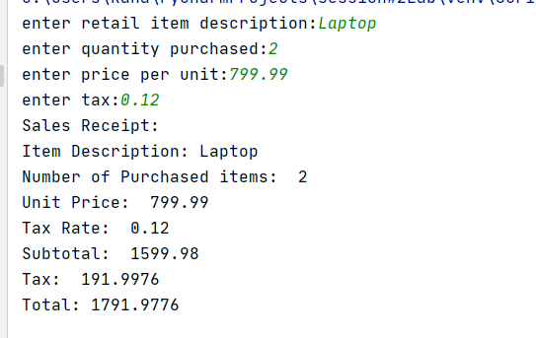

* Make sure to include doc-string in every function

**Take Home lab:**

1. Create two files in project Lab2 one with the name utilities.py and one with the name main.py
2. In file utilities.py implement the following:

* import module math from Python Standard Library
* Create the following functions:
  + Function calculate_circle_area(), the function takes the radius as a parameter, calculates and returns the area() of the circle.

**Hint: circle area is computed using the formula $area=π* r^{2}$**

**Use the statement math.pi to get the value of $π$**

* Function calculate_sphere_volume(), the function takes one parameter which is the radius, calculates and returns the sphere volume.

**Hint: the sphere volume is calculated using the formula**

* + Function calculate_BMI()[body mass index], the function prompts the user to enter the weight in kilograms and the height in meters, calculates and returns the body mass index.

**Hint the BMI is calculated using the formula BMI =**

* + Function calculate_hypotenuse(), the function prompts the user to enter the lengths of side A and side B of a right triangle. The function will calculate and return the length of a right triangles hypotenuse

**Hint use function hypot() from module math**

1. In the file main.py import module utilities
2. Create a main method and implement the following :

* Prompt the user to enter the radius of a circle, call function calculate_circle_area passing the radius provided by the user and display the result.
* Prompt the user to enter the radius of a sphere, call function calculate_sphere_volume() passing the radius provided by the user and display the result.
* Call function calculate_BMI() and display the result.
* Call function calculate_hypotenuse() and display the result.

Here is the expected output of main.py

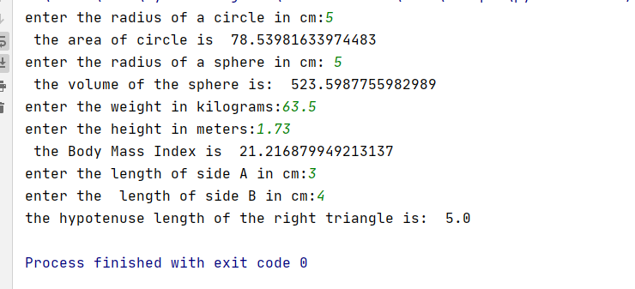

Best Practices

* Variable names are descriptive and should be lower_snake_case
* function names should be lower_snake_case
* All functions include Doc-String comments

Submission

Submit zipped folder containing project Lab2 to the dropbox before the deadline.